Shanika Isaacs

CIM 111

Online Marketing & SEO Plan

1. What areas/locations are you target and why? The area that this marketing plan would be targeting for the client’s website would be a 15-mile radius of Miami. The reason for this is as a result of the client not wanting to leave Miami, Florida for work. Therefore, in targeting the Miami market in the Communication field, this would help the client in a narrower and more specific search. This would reach a potential audience of 18,716,831 people. This overall plan would be in appropriate budget of $1000 falling at approximately $669. Thus, client’s dreams and hopes would initially be targeted towards the Miami market due to the area’s favorable climate, familiarity and locations to transport to for interview purposes.
2. List what keywords are you going to use and buy? The keywords that would be used and bought would be Public Relation Specialist, PR Specialist, Web Designer, Freelance Journalist, Webdesign, Journalism and Journalist.
3. 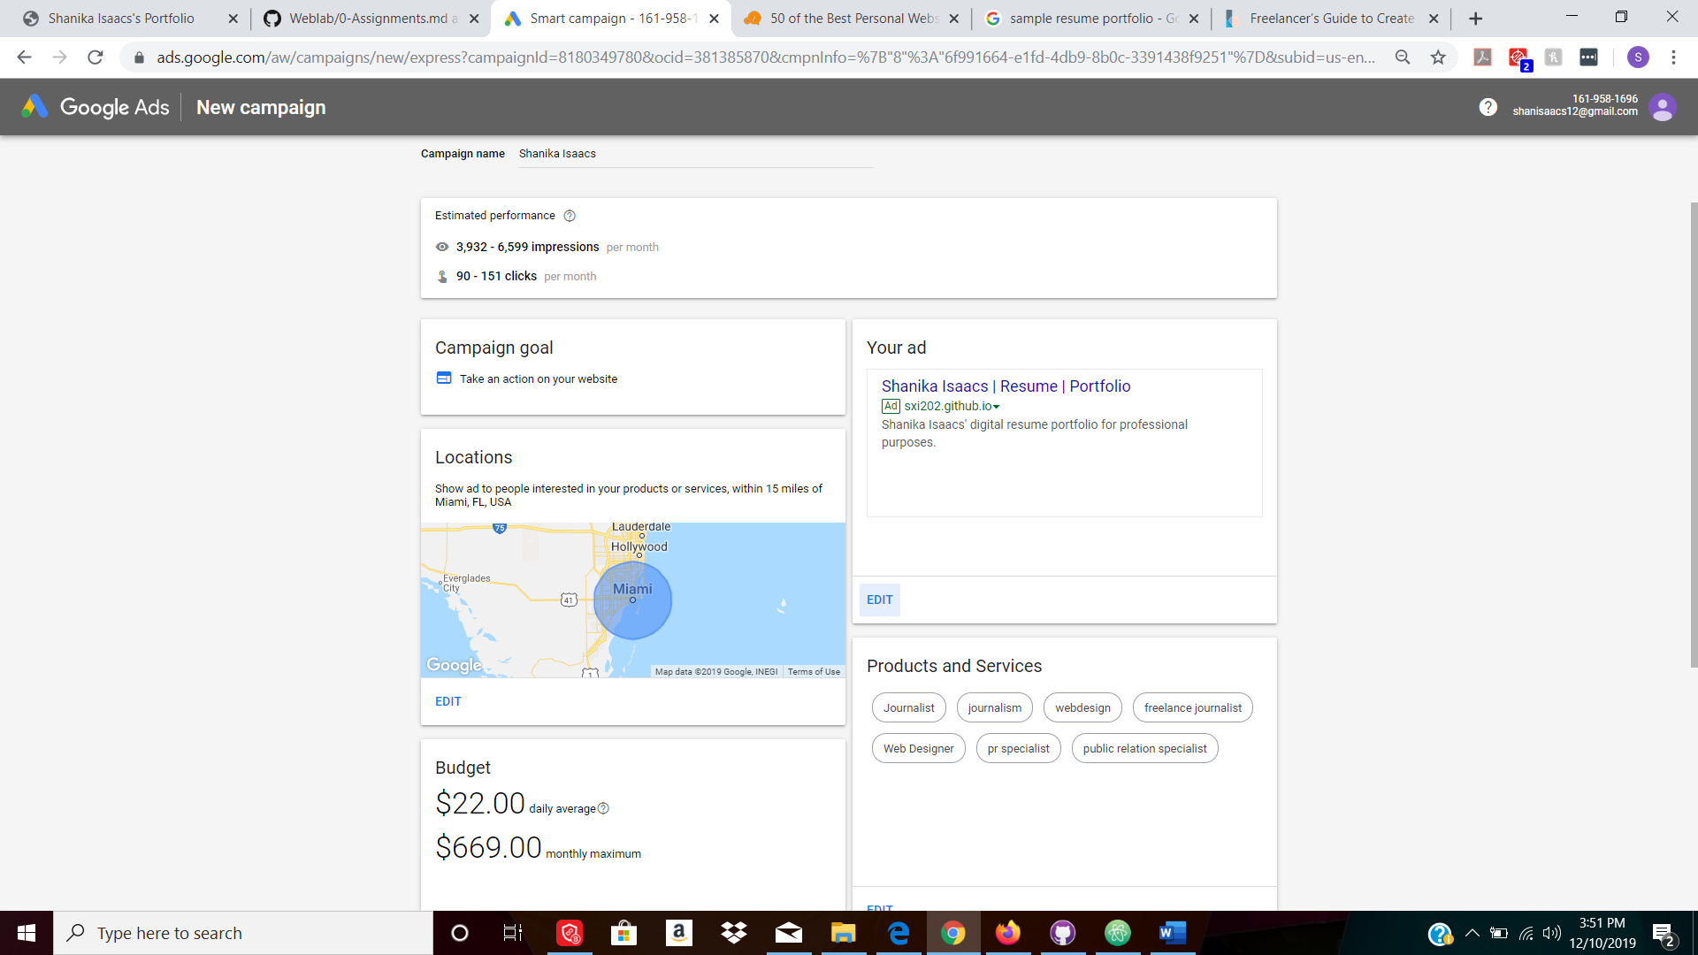What is the duration of your campaign? Try to explain your reasoning on the duration. Is there an event, etc? The duration of this campaign would be for an entire month. This search time would give the client enough time to send out resumes, check out potential work sites and make introductions for directing employers to their website.